**CUMANN LÚTHCHLEAS GAEL**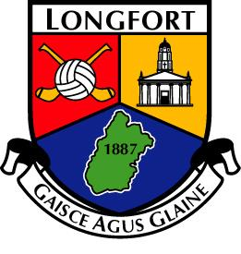

**Coiste Chontae Longfort**

**-ROINN NA GAEILGE AGUS CULTÚIR-**

**Scéim Deontais don Ghaeltacht**

**Foirm Iarratais 2025**

Ainm agus Sloinne an iarrthóra ___________________________________________

***(Name & surname of applicant)***

***(One Entry per Family)***

Seoladh ***(Address)***  ___________________________________________

___________________________________________

Dáta Breithe ___________________________________________

***(Date of Birth)***  ***N.B. Applicants must be 13 years or older on 1st Jan of application year***

Ainm na Scoile ___________________________ Bhliain ar Scoil __________________________

***(Name of School) (Year at School)***

An Club C.L.G. no Scór atá í do cheantar __________________________________________

***(Name of G.A.A. or Scór club in your area)***

Uimhir Bhallraíochta ______________________

***(Membership Number (Contact Club Secretary if this is not known to you)***

Ainm an Choláiste _______________________________________

**(Name of Irish college)**

Síniú an iarrthóra ___________________________________________

***(Signature of applicant)***

**I/We have read the conditions of the above scheme, and I/We agree to be bound by same**

Sínite Tuismitheoir/Caomhnóir

***(Parent/Guardian)***

___________________________________________

***(Signed)***

Uimhir Fóin ___________________________________________

***(Phone No.)***

Ríomhphost _____________________________________

(**Email**)

Dáta an iarratais seo ___________________________________________

***(Date of this application)***

N.B. Caithfidh an t-iarratas seo a bheith ar ais ag an t-Oifigeach Gaeilge agus Cultύir.

***CLOSING DATE FOR APPLICATIONS – Monday 31st March 2025 @ 6pm***

***Completed application forms MUST be returned on or before the closing date highlighted above:***

***Email Form to: irishculturalofficer.longford@gaa.ie***

***Post/drop form into the office Longford GAA, Glennon Brothers Pearse Park, Lisbrack Rd. Longford N39 VY28***